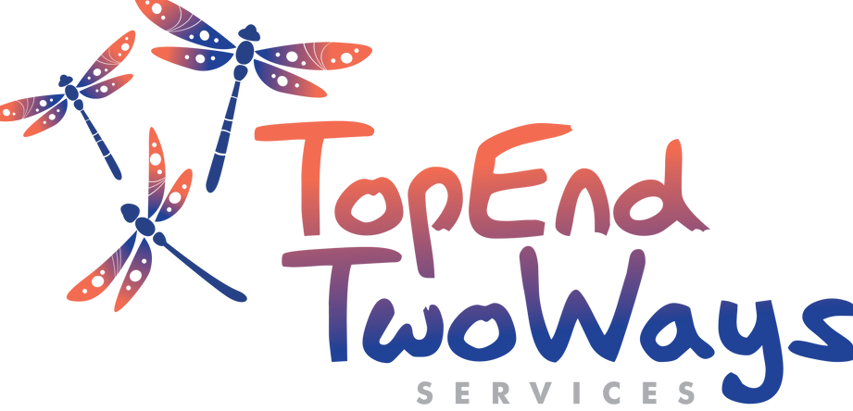

Organisation
Contact Name
Contact Number
Email
Location
Number of participants
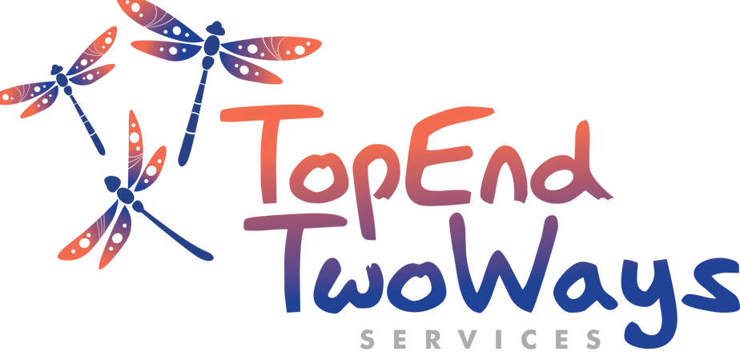

TETWS Training Enquiry Form

Positive Duty –Workplace Anti-discrimination Obligations
TETWS Training Enquiry Form
Organisation Contact Name Contact Number Email
Location
Number of participants
BASIC: No prerequisites 1.5 hours on your site or online Cost max 15: Government & private $1100 + GST





Cost max 15: NGO $850+ GST
Self-care – Safeguarding your staff to remain strong
The Effects of Trauma and Domestic Violence on Babies and Children
Professional Boundaries in Early Childhood Learning
Mandatory Reporting in the NT

An Employer’s Obligation to Employees Experiencing Domestic Violence
Positive Duty – Workplace A Positive Duty – Workplace Anti-discrimination Obligations
Vicarious Trauma and Self-care
To book please contact:
0461 359 485
info@tetws.org.au tetws.org.au
Please Tick Below
Includes an individual competency assessment to meet mandatory requirements of NT
Anti-discrimination Act 1992
Learning outcomes:
What the law means Who does it apply?
When does it becomes effective? What are the protected attributes?
How to take positive action to prevent or eliminate discrimination

An Employer’s Obligation to Employees Experiencing Domestic Violence
BASIC: No prerequisites 1.5 hours on your site or online Cost max 15: Government &amp; private $1100 + GST Cost max 15: NGO $850+ GST
Learning outcomes:
What are the legal obligations?
What is domestic and family violence? What are the signs of DFV?
How DFV affects the workplace What supports are available?
Developing a workplace policy


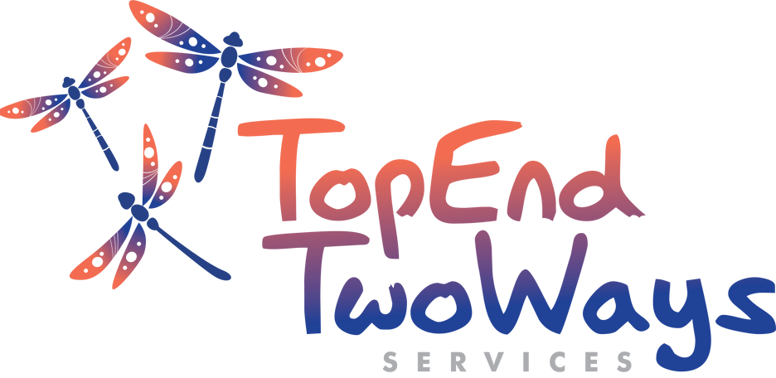




Mandatory Reporting in the NT
Vicarious Trauma and Self-care
BASIC: No prerequisites 2 hours on your site or online Cost max 15: Government & private $1100 + GST Cost max 15: NGO $850+ GST
Learning outcomes:
What is vicarious trauma?
Do you have vicarious trauma? How to address vicarious trauma What is self-care?
What is a self-care plan?
Self-care – Safeguarding your staff to remain strong
BASIC: No prerequisites 1 hour on your site or online Cost max 15: Government & private $850 + GST Cost max 15: NGO $600+ GST
Learning outcomes:
What is self-care?
What is a self-care plan?
Building self-care into your daily routine Self-care check-up
To book please contact:
0461 359 485
info@tetws.org.au tetws.org.au
BASIC: No prerequisites 1.5 hours on your site or online Cost max 15: Government & private $1100 + GST
Cost max 15: NGO $850+ GST
Learning outcomes:
Mandatory reporting of domestic family violence What is DFV?
How do you report it?
Mandatory reporting of child abuse and neglect What is child abuse and neglect?
How do you report it?

A Professional Boundaries in Early Childhood Learning
BASIC: No prerequisites 2 hours on your site or online Cost max 15: Government & private $1100 + GST Cost max 15: NGO $850+ GST
Professional boundaries are essential in early childhood education. As role models for the next generation, educators carry a deep responsibility—making ethical awareness and cultural competence vital to their work.
Learning outcomes:
What are professional boundaries? Why are ethics important?
Setting boundaries
How to re-establish boundaries Basic self-care

To book please contact:
0461 359 485
 info@tetws.org.au tetws.org.au

